SUPPLEMENTAL BID BULLETIN No. 2

Title of the Project : Procurement of ICT Equipment for the OACSAS

Request for Quotation No. : 2023-250 Shopping (b)

This Supplemental Bid Bulletin is issued to all prospective bidders announcing the extension of submission of quotation, to wit:

PARTICULARS | FROM | TO
Procurement of Various ICT Equipment for the OACSAS | Extension of submission of quotations from  November 28, 2023, 9:00 AM | December 1, 2023,  3:00 PM

Bidders may electronically submit their quotation thru csc.ofam.pmd@gmail.com or drop it personally in the Bid Box located at the Procurement Management Division – OFAM, Basement, CSC Main Building, CSC-Central Office.

Please be guided accordingly.

PRESENTACION M. GAJES
Supervising Administrative Officer
PMD-OFAM
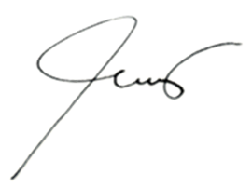
November 22, 2023

